**Learn To Skate/Academy Ice Show Application**

Skater’s Name_______________________________________ Girl/Boy Age_____________

Current Class Level (current level enrolled in)___________________________________________________

Adress______________________________________________________________________

Phone___________________________ e-mail_____________________________________

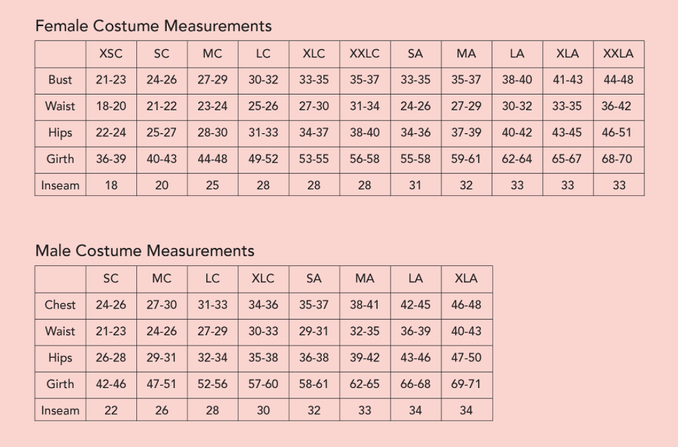

Costume Measurements: The most important measurement is the **girth** measurement. Measure girth from the center of the right shoulder, through the crotch, and back to the starting point. **Hold tape loosely.** When in doubt, let the girth measurement be your guide. Please include all measurements.

Bust _____ Waist _____ Hips _____ Girth _____ **Size ____________________**

The undersigned understands that participation in this activity is completely voluntary and that the activity is being offered for the benefit of the participant. The undersigned agrees that the Duluth Figure Skating Club shall not be liable for any claims, injuries, damages, of whatever nature, incurred by the participant due to the negligence of the Club, its volunteers and staff, arising out of, or connected with, the activity. On behalf of himself/herself and the participant, the undersigned expressly releases and discharges the Club, volunteers and staff, from any such claims, injuries, or damages.

__________________________ ____________________________________

Dated Parent/Guardian/Participant

**Registration Deadline: $95 January 13, 2020**

Payments can be made to the DFSC by check or Pay Pal at duluthfsc.org

Send Form to: Heather Seyfer Questions: heather_seyfer@hotmail.com

1101 Valley Drive 218-525-0524

Duluth, MN55804

**Learn to Skate/Academy Ice Show Information**

The ice show will be held on Saturday, March 28th . We will be having two shows at 2:00pm and 7:00pm. There will be a dress rehearsal Friday March 27th . The show will also include groups and soloists from the Duluth Figure Skating Club.

**Registration:** The registration form for the 2020 spring ice show is attached. Registrations are due by January 13 to receive discounts on costumes and to ensure early arrival of costumes for the pictures. Groups for the ice show will be based on the level the skater is presently working on during the winter session. Please pay special attention to this. This will be the group that they will be with for the show. The skaters will not be able to change level after they pass another test. Some DFSC Academy members will join learn to skate groups. DFSC coaches will make recommendations to which groups they should be placed in.

**Cost:** The cost is $95 until January 13, 2020. This is for costume, additional instructor time, ice time, and 2 tickets to the show. Checks should be written out to the DFSC or use pay pal at duluthfsc.org. People who would like to pay in installments may pay $55 now and $40 before the first practice. Late entries are based on costume availability.

**Practices:** There will be four 30 minute practices: Saturdays, March 14 and 21, 11:15-12:15, Sunday, March 15 and 22, 2:00-3:00. These dates are subject to ice availability and may change. You will receive more information later about specifics of practices and which coach will be with group. Please contact that group coach about any absences. There will be a $10 late fee for any applications taken after the costumes are ordered. They will be added if the costumes are available. Costumes that need to be exchanged for a different size will have a $10 additional fee. There may be a small prop fee added if needed for their group.

**Pictures:** Pictures will be taken on March 21.

**Tickets:** Tickets will be on sale during rehearsals and lessons prior to the show. Please indicate on your form if you are willing to volunteer for the show. Sign-up forms will be posted at the rink closer to the date of the show.

**Questions:** If you have any questions or concerns, please contact:

Heather Seyfer @ 218-213- 3960 or [heather_seyfer@hotmail.com](mailto:heather_seyfer@hotmail.com) from the Duluth Figure Skating Club. You can find registration forms on the duluthfsc.org website.

**Tights**

**We are offering Dancing Fair run resistant footed tights to go with the costumes or for extra warmth. There is a new color this year. Please pre-order to guarantee the size you need.**

**Children’s Size Chart----- Price $6**

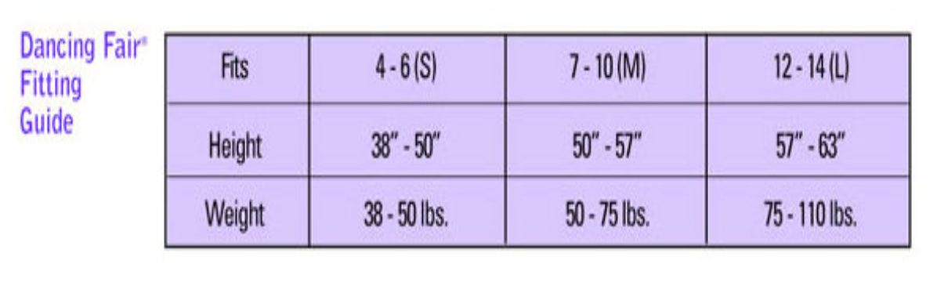

**Adult Size Chart-----Price $7**



Name_______________________________

Size______

Quantity_____

Total________